**Nightlights and Property Rights in Nagorno-Karabakh: Economic growth under external threat to property rights through satellite luminosity data**

Chad Kalil

Econ 627

Dr. Charles Becker

22 November 2020

# I Introduction

This paper looks to discover the impact of property rights that are relatively more secure from outside threat on economic growth in a contested region. Nagorno-Karabakh Republic (also known as the Republic of Artsakh but addressed in this paper as Nagorno-Karabakh) provides our area of analysis. The contested region is made up of a majority of ethnic Armenians but is surrounded by the Azerbaijani state and claimed by it despite the people’s stronger links to the Armenian state. For the Armenians who reside there since the fall of the Soviet Empire and conflicts in the region at the time, they have been under constant external risk. In theory, the distance from the formal Azerbaijani border represents a proxy for the level of risk to property rights, allowing one to determine whether it is a causal factor on the economic development of the region from 1992 through 2013. However, due to the lack of thorough economic data in such a contested region, this paper utilizes night-light data for the region as a proxy for economic activity. Given the recent spotlight shown on the region due to a flaring up of tensions and the beginnings of armed conflict, this work comes at an important time as the previous threat becomes all too real for residents. Furthermore, this paper will utilize a nearby Azerbaijani region as a control, to isolate causal factors to purely external threat as much as possible. We find that distance from the border, and in turn external property right threat does serve as a deterrent to economic growth in the Nagorno-Karabakh region, though exploring this problem further in other areas remains necessary for firmer conclusions.

# II Historical Background

The history of the Nagorno-Karabakh is vaster and more complicated than this paper could hope to address in an efficient way. However, we attempt to give a basic understanding of the demographic shifts and conflicts that have laid the stage for the situation on the ground in the present. This will begin with when The Russian Empire (the precursor to the USSR Government) actively took the region. Prior to that the region has a rich history, which the reader is encouraged to look into separately for further table-setting information.

Nagorno-Karabakh first came under Russian control in 1805 under Tsar Alexander as a protectorate, though it was truly brought into the empire in 1813 following the signing of the Treaty of Gulistan with Iran following the Russio-Persian war. The region at the time was relatively small, with a survey commissioned identifying 69 Armenian villages, and 7 Azerbaijani villages. As was common for many Russian empire surveys, it did not fully consider nomadic populations, which at the time were primarily Azerbaijani.

The next significant shift came in the Soviet epoch, as following the turmoil of the Russian Revolution of 1917, the Armenian-Azerbaijani war was fought over several regions in the area in the power vacuum, including Nagorno-Karabakh. This period, along with the preceding Armenian genocide throughout the Ottoman Empire, formed much of the basis of modern strife and is perhaps most starkly exemplified by the Shusha Massacre in 1920. During it, the territory’s capital saw its Armenian sections devastated, in targeted attacks. Following the Bolshevik takeover of Azerbaijan (aided by Soviet forces) during the war, as well as later of Armenia and Georgia, the Soviet Union partitioned the contested areas in 1923, with Karabakh under the control of Azerbaijan, despite the heavily Armenian population. This would become the Nagorno-Karabakh Autonomous Oblast and was more the result of decision by the Stalinist regime to attempt to solve some of the conflict that had plagued the region (Makili-Aliyev).

Soviet control of the region proved calming, as the region was free of conflict during the height of its reign. However, the seeds of conflict remained, and with the hints of degrading Soviet power in the late 1980’s, the issue came to the forefront once more for the largely Armenian population of the region. This was led by a regional party, with whom Gorbachev negotiated over the unification of the region with Armenia, eventually rejecting the requests despite the regional support requesting transfer. Eventually following this failure, led to an independence referendum in December of 1991 with 99.9% of voters supporting independence amidst a boycott by the local Azerbaijani population (Ministry of Foreign Affairs).

Upon the demise of the Soviet state, the corresponding lack of Soviet power proved the spark that lit the matchbox the region had become in the past few years, with regional conflicts exploding into a full-scale war between the two neighboring states. What followed was a bloody and terrible conflict that further bred resentment and fear in the regions, especially for the native ethnically-Armenian population. This also resulted in a heavy influx of Armenians, as they fled Baku and other enclaves in Azerbaijan that had previously been relatively safe for them under Soviet rule. Eventually after Armenian forces conquered the region, talks concluded with Russian support, bringing a cease-fire, but no true resolution to the issue been under discussion. In May 1994, the Bishkek Protocol was agreed upon by the two parties, with the goal of a future peace agreement to be hammered out (Bishkek Protocol). However, this effectively became a frozen issue, as no further agreement was reached. This left Nagorno-Karabakh hanging in limbo, with the Republic of Artsakh unrecognized, a situation that largely continued until conflict erupted once more in 2020. The region remained surrounded by recognized Azerbaijan on all sides, leaving it in limbo as an isolated island with potentially hostile forces around it.

The Republic of Artsakh is currently recognized by no UN nations. Its international status is in a relative grey area, though it has been recognized by a number of other states in similar situations. Armenia has not officially recognized it, but officials up to President Serzh Sargsyan consider it “an integral part” of Armenia (Vestnik Kavkaza). On the other hand, Azerbaijanis see the territory as one stolen from them amidst a repopulation of their peoples from various ancestral homes. This lack of recognition and contested status means the people who live within are in an unstable environment, never sure that they can fully invest in a stable future. Further exacerbating are relatively frequent skirmishes along the border, as the two nations continued to jostle for position. The recent fighting of 2020 broke this “cold war” as the battle flared.

Most of the recent fighting has been focused on the areas that had been the focus of the 1993 war. While the fighting is not relevant to what this paper covers, it nevertheless represents an important shift in recent relations. As of the date of this paper, the two sides had come to a tentative ceasefire agreement that left Azerbaijan with much of the territory that it had captured in a recent push. After Russian oversight on the agreement, their troops will serve as the peacekeeping force in the area, though given the lack of precedent in coming to a firm agreement following a ceasefire, there is no guarantee this will fully resolve the ongoing conflict.

# III Literature Review

Various other authors have tackled the task of showing how property rights can influence economic growth in different situations, but the majority have looked at it from a developmental standpoint over long-term periods rather than acute pressure on these. Notable among these papers are Acemoglu et al.’s seminal paper on disease environment’s interaction with secure property rights and how these then led to long-term economic development. This paper also showed how institutions that were more protective of property rights tended to foster long-term development (Acemoglu, Johnson, & Robinson, 2000). Our paper looks to branch off this root, as we explore property rights in a shorter period. Where this paper diverges from these is in a more prominent focus on one region as well as an acute focus on property rights in response to external threat, in this case the country being surrounded by Azerbaijan. Furthermore, it provides a possible case study for an acute shift in relative protections following the downfall of the Soviet state that previously provided these, though we lack some of the historical satellite data to fully explore this. This model could be duplicated in various other regions that undergo a significant shift in outside threat. Among possible interesting case studies and extensions to this paper, could be Eastern Ukraine, Palestine, or Northern Ireland.

This paper also owes a debt to its precursors that focused on night light data as a proxy for economic activity. Chief on this list in the literature is the seminal paper by Elvidge that looks at the data and attempts to link it to population and energy consumption (Elvidge, 1997). Numerous other authors have taken up the banner of using this new data set in areas with little data or using it to subdivide regions into non-traditional boundaries, and this stems from a similar tree. Specifically in terms of GDP growth, this paper pulls much from Henderson, Storeygard and Weil’s paper that used nightlights to measure growth in Sub-Saharan Africa (Henderson, Storeygard, and Weil, 2012). That paper undertakes a similar method to ours, in measuring and outputting economic numbers for an area with poor statistical coverage, but does not look to link it an explanation for the growth as this will do. In addition, our paper does not focus specifically on translating nightlights to GDP, but rather the effect of the external threat. Rather, we prefer a measure that focuses on a growth in luminosity over the years, without extrapolating a direct effect on GDP. That said, their analysis of the data provides a strong foundation for an introduction into this realm of inquiry and is worthwhile reading for anyone new to the subject.

Finally, this paper draws from a deep well of studies that have attempted to circumvent inability to measure GDP, whether for data inaccessibility reasons, or historical reasons. In using an alternative method to track economic growth, we follow in the footsteps of many authors. This paper was specifically influenced by anthropological measurements of heights as a proxy for growth in the Soviet Union (for example by Boris Mironov) as well as David Good’s estimation of output from factors such as mailed items, school enrollment and deposits in savings banks among others (Good 1994; Mironov 1999). Given the murky world in which we live, being able to operate without clean data is vital and this paper aims to further expand upon that and provide a possible framework for other similar areas.

# IV Data

Summary Statistics of Average Luminosity per Grid:

|  |  |
| --- | --- |
| Standard Deviation | 1.565 |
| Mean | 0.4635 |
| Median | 0 |
| Skewness | 6.44 |

This paper uses broadly available night-light data from the National Centers for Environmental Information whose Nighttime Lights data set encompasses 1992-2013. The dataset measures the luminosity of areas at night throughout the world. Using the ArcGis program as well as country frames, the region of Nagorno-Karabakh is isolated and the change in luminosity measured throughout the years. Luminosity data is subdivided into various regions based on a gridding format within Nagorno-Karabakh. These grids take the size of 3x3 arcminutes throughout the country (1 arcminute being equivalent to 1/60th of a degree). We do include some smaller grids along the border to account for the entirety of the area, but the data in these are mean-averaged to account for the smaller size and additionally the size of the grid is included in the regression as a control. In total, 240 grids are defined in the dataset that makes up Nagorno-Karabakh.From there, this data is used as a noisy indicator of economic activity, and regressed against distance from the Azerbaijani border (relative to the center of the grid), which serves as a proxy for level of property right threat from any potential attack. We take this distance as a proxy for level of property right threat due to the continued skirmishes that have been seen along the border, and the constant latent threat of all-out war. Given that regions on the border and closer to it tend to be more vulnerable to outside attack and the risk of destruction in any conflict, distance was chosen, though it may not operate uniformly everywhere. We further include a control dataset from Azerbaijan in the Barda Rayon that is discussed later in this paper.

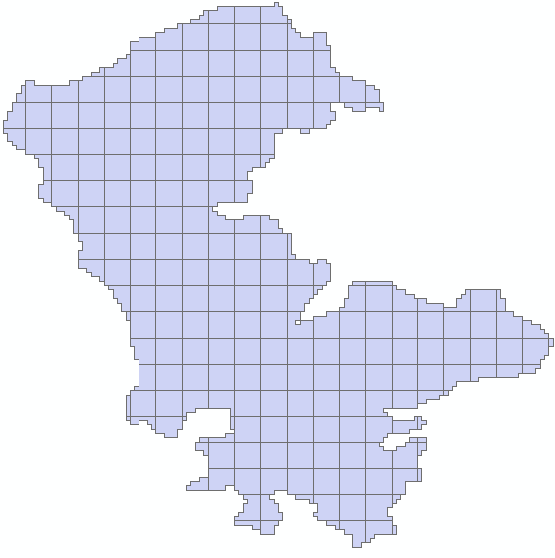

Figure 1: Gridded Area of Nagorno-Karabakh

The advantage of this dataset is that given the contested nature of the region, there is a lack of concrete data that can be trusted. While the paucity of data is itself a problem, even that we have (such as a census taken in 2005) is often contested, due to both Armenia as well as Azerbaijan’s attempts to exert influence in the area. While we do have likely more accurate historical data such as the Soviet census of 1989, since the demise of the Soviet Union as a neutral factor, data of the region are unreliable. The Soviet census of 1989 does provide an interesting datapoint, as it showed a population that was 77% ethnic Armenian. Relative to earlier censuses, this was driven by growth from ethnic Armenians in the region, suggesting that a continuation of trends would see this percentage expand over the years without the influence of other factors which likely contributed.Per the censuses undertaken by the Nagorno-Karabakh government, the numbers for ethnic Armenians in the region is now 99.7% with the rest of the population largely Russian and little trace of any Azerbaijani population. Having such a high percentage lowers the risk of potential confounding data from the Azerbaijani population. It does mean that there are significant portion of displaced Azerbaijani’s who wish to return to the region, something further discussed in the control region. If they were a significant percentage, certain regions could be more or less immune from the distance to border, as theoretically their measure of outside threat would be effectively null. While the conflicts in the early 90’s likely contributed to this dramatic shift, it must be kept in mind that the region is still claimed by Azerbaijan, so data that suggests the claim is invalid is of course in the interest of the region’s government to print. Of note is that the regions covered by the Soviet Autonomous Oblast do differ slightly between the current-day republic, which may be cause for some of this discrepancy.

One of the issues with night light data is that unfortunately, the nature of it can prevent a full measure of confidence in the findings. While measures of luminosity often trend with economic indicators and appear to be strongly correlated, it is noisy. There may be a variety of other factors creating error in the data, from development that was relatively luminous, or expansion of GDP in other areas that do not create luminosity. Specifically, much agricultural development will not be captured by the nightlights, so if an area’s economic growth was more focused on agriculture, this would misrepresent the actual number. Furthermore, our data set not being current may limit potential to see as deep of a connection from just a 21-year period. This is especially disappointing given the recent escalation in tensions, from which we may expect to see agents react by further downshifting investments in response to heightened property rights risk. However, the recent movement may lend itself to a follow-up paper later to see the response to an acute rise in risk taking place over a short time-period.

What we do see in the data quite clearly is a massive amount of additional luminosity in the data from the 1992 start date. It is important to note that much of this correlates with regional growth and recovery in the immediate post-Soviet era, and is further exacerbated by the war in the region. At the beginning of our sample in 1992 the average light per pixel level was just .0695 and the highest light capture is a 15. By the end dateof 2013, we climb to an average light for pixel of 1.353, with the highest light level recorded 58. This data provide a nice sanity check for our broad use of night lights as an economic indicator, suggesting it is not inherently flawed. Local government statistics have cited explosive economic growth, though these numbers may contain some bias, which our luminosity data can look to cut through while corroborating the general growth pattern. In addition, some of this may be coming from the low point our data starts from, following an intense conflict in the region that proved destructive for many. While the dataset may be including some “catch-up” growth in making up for lost time, this does not take away from the analysis itself, as in theory the causal factor on difference in growth rates should still be effective. To compensate for this, we include the baseline 1992 value of luminosity in some of our later regression, and it is indeed negative as one would expect.

The explosive economic growth seen does align itself with the numbers seen in both Armenia and Azerbaijan. Per data from the World Bank, Armenia’s GDP growth rate over the same time period has been 6.1% (coming off a -41.8% year in 1992, our base year), while Azerbaijan’s was 6.6% (-22.6% in our base year). Both these numbers are also relatively lower due to the worldwide recession of 2008-2009, which likely would have had a lesser effect on Nagorno-Karabakh. (World Bank) Given this, it seems a control region in Azerbaijan remains valid, as this provides a sanity check that growth in the areas surrounding has been similar.

One important thing to note is the proportion of light that is concentrated. The Artsakh statistical service reported the 2005 population was roughly split 50/50 between urban and rural residents. The night light data set shows that a full 68.75% of the grids the data was collected for in 2013 had 0 visible luminosity, and much of the mean values were carried by a few small clusters of extremely active light. This may suggest that economic development has been contained mainly to these population hubs, or that elsewhere it is dominated by almost entirely agricultural activity. These numbers do not suggest anything overtly unusual, as one would expect rural development to be largely agriculturally based, but perhaps linked with more movement into the cities and towns of the region.

This concentration did begin to lessen in later years, as we saw some regions that had heretofore been underdeveloped began to register on the map with lower luminosity ratings. An important development for the region, this points to a possible expansion of the growth to the surrounding areas, and perhaps a transition for regions that before were purely agricultural. It is possible this is indicative of a broader shift in the economy being captured in the data, perhaps a modernization movement as people move away from as agriculturally focused lifestyles. The general trend of percentile of grids with no luminosity measure in its respective year began to trend heavily downward in 2001, after an initial slow decline. While we do see what appears to be a temporary spike later in the data, it soon reverses itself, continuing the prior trend. Of note, this peak upward in 2009 came alongside a broader worldwide recession that also heavily impacted Armenia and Azerbaijan, suggesting it was likely the cause.

The region we take as a control across the border in Azerbaijan is the Barda Rayon (see appendix 2 for visual representation of luminosity in the region). The region has relatively similar data points to Nagorno-Karabakh and is close enough to the border to still feasibly be under property right threat if it were Armenian controlled. However, given its Azerbaijani population in the country, it should be safe, and thus immune to the influence of the distance to the border given the attack would likely come from Armenia proper, not Nagorno-Karabakh. The statistics for the region indicate higher luminosity’s in 1992, having been spared wartime destruction, with a peak of 44 in a pixel, and similar endings in 2013, with a peak of 57 per pixel. The region’s average luminosity begins at 4.0 per grid, and ends at 7.0 per grid, compared to numbers of 0.11 to 1.24 respectively for Nagorno Karabakh. Given the wartime destruction of Nagorno-Karabakh in 1992, it was difficult to find similar regions in Azerbaijan, but the central cluster here shares many similarities. The luminosity is similarly clustered around one growth point, the city of Barda and surrounding regions. Some of these residents are also likely formerly from Nagorno-Karabakh. While not ideal due to the higher stating luminosity, and a relatively more urban population, it was the closest approximation to be found and matches up well to the trends we see in the urban areas of Nagorno-Karabakh.

# V Model

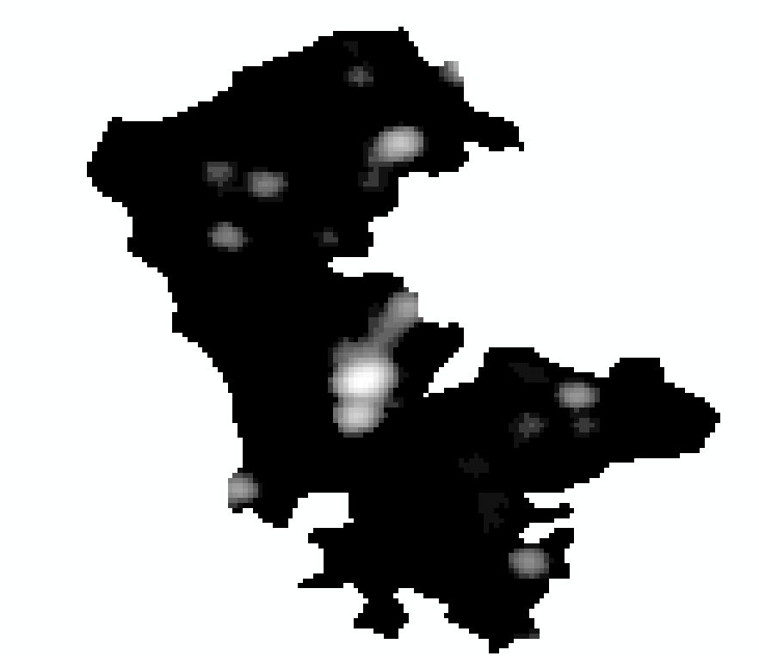

Figure 2:Nagorno-Karabakh Luminosity in 1992 Figure 3: Nagorno-Karabakh Luminosity in 2013

For our first run of the data, we run a simple OLS regression on the change in lights versus the size of the grid, as well as the distance from the border as a starting point. While this is a rudimentary model, it can provide a good starting point for tracking how the data changed over the entirety of the period and whether our initial guess that distance from the border would have an effect can be supported. This initial regression takes the form of:

**Lt=Ƀ0+Ƀ1D+ Ƀ2D2 +Ƀ3A+Ꜫ**

**First Model Regression**

|  |  |  |  |  |
| --- | --- | --- | --- | --- |
|  | Estimate | Std. Error | T value | Pr>(|t|) |
| Intercept | .4767 | .5912 | .806 | .42084 |
| Distance | 21.8441 | 6.9384 | 3.148 | .00185** |
| Area | -283.2357 | 363.7821 | -0.779 | .43700 |

**=significant at the 99% level R2=.0435

For this model we have C being the total change in lights for a region over the entire period, D being the distance from the border, A being the size of the grid used and Ꜫ the error term. What we find from this initial work is that the distance from the border is strongly significant, with an estimated value of 21.84 on its beta. This indicates that increasing the distance from the Azerbaijani border by 1 decimal degree increases the average value of the grid’s luminosity by 21.84, quite a significant shift when our highest light level recorded is 58. Of note, the farthest any of our grids is from the border is .162 decimal degrees, limiting the total effects. This may help explain why we see the highest luminosity values in the region near the centers, as far from the border as is effectively possible in such an isolated country. Area does not appear to influence the data, a comfort as though most grids had a consistent size, some were smaller and a possible source of error after clipping around the country border. The R squared registered for this, is 0.0435. While this may appear low, in an area of constant compounding such as economic growth, a 4.4% shift in rates can have a drastic effect over the years. However, this simplistic model will be expanded further on, into a more complex time series analysis rather than just raw growth rates.

Moving onto the more complex autoregressive model, we maintain the variables from before, as well as adding two more, for luminosity in the grid the year before as well as two years ago. This will allow us to define the growth more finely per year, isolating away from potential differences that have created compounding errors over the entire data set. To further improve specification, we estimate the current year’s luminosity levels as a factor of the two prior years by using lagged data starting in 1994, giving us a formulation of:

**ΔLt =Ƀ0+Ƀ1D+Ƀ2A+ Ƀ3Lt-1+ Ƀ4Lt-2+Ꜫ**

**Second Model Regression**

|  |  |  |  |  |
| --- | --- | --- | --- | --- |
|  | Estimate | Std. Error | T Value | Pr>(|t|) |
| Intercept | -0.015 | 0.02648 | -0.567 | 0.571 |
| T-2 | 0.59833 | 0.01444 | 41.443 | 0*** |
| T-1 | 0.52098 | 0.01265 | 41.175 | 0*** |
| Distance | 0.56280 | 0.31491 | 1.787 | 0.074. |
| Area | 11.05416 | 16.30628 | 0.678 | 0.498 |

***=significant at the 99.9% level. .=significant at the 90% level R2=.8963

Unsurprisingly, both prior light levels are extremely significant to the current light level, as one would expect with both terms contributing significantly to the current term. The increasing coefficient further back likely signifies the compounding effects of growth, as the closer to the current time period we’d expect a higher level, and less time for it to make a difference.

More relevantly to our a priori assumption, the distance from the border remains statistically significant, though at a lesser level. The coefficient has also significantly decreased, with a portion of that attributable to the move towards measuring by yearly observation rather than the entire time periods growth. Nonetheless, there remains a separate drop, suggesting that much of the initial impact we saw may have been related to autocorrelation over time. Likely part of the initial observation we had is that the higher economic growth regions in the area are located centrally, which may prove to be an accident of the region’s historical development.

Notably, when we run the regression with the same format but modifying distance to be distance squared, it becomes more significant

**Third Model Regression**:

**Lt =Ƀ0+Ƀ1D2+Ƀ2A+ Ƀ3Lt-1+ Ƀ4Lt-2+Ꜫ**

|  |  |  |  |  |
| --- | --- | --- | --- | --- |
|  | Estimate | Std. Error | T Value | Pr>(|t|) |
| Intercept | -0.012 | 0.02669 | -0.452 | 0.6516 |
| T-2 | 0.59824 | 0.01444 | 41.440 | 0*** |
| T-1 | 0.52086 | 0.01265 | 41.166 | 0*** |
| Distance2 | 3.67669 | 1.87266 | 1.963 | 0.0497* |
| Area | 16.55696 | 14.11174 | 1.173 | 0.2407 |

***=significant at the 99.9% level. *=significant at the 95% level R2=.8963

What this may suggest, is that rather than the linear relationship we had assumed as a prior, it is rather quadratic. This intuitively makes sense, as it would suggest threat is extremely high near the border, but drops off as one moves farther away. In other words, Nagorno-Karabakh’s residents who are living extremely close and constantly aware of the external threat posed by the Azerbaijani state tend to be much more cautious. The R-squared values do not change, suggesting that the regression is still largely being driven by the time-lagged terms one would expect.

This regression is robust to removing the control terms of the area, as well as either of the separate prior years taken on. In all cases, this increases the significance of distance from the border as a causal factor, moving it above 99% significant level. Looking at these changes may provide further support for conjecture that distance from the border is operating significantly on economic growth if one accepts that luminosity is an acceptable measurement of such.

When looking at the residuals of the regression, there seems to be a consistent pattern in which the largest residuals are found in specific grid areas. These tend to be alongside another grid area that stands out (suggesting some possible spatial autocorrelation) and in grids that saw explosive growth in luminosity near the back end of our sample. This may suggest that as time passed and the region got farther away temporally from its prior conflict, the effects of distance as a causal effect lessened. In practice, this would represent the people’s living in the area recognizing the lack of recent disturbance and “letting their guard down” as they deemphasized the risk of outside threat in their internal utility calculations. This effect appears to us as larger positive residuals near the back end, as distance no longer drags down the economic growth, and thus luminosity expands further as we approach the end date of our data.

One worry about the regression we show is the potential for some spatial autocorrelation that is warping the distance from border coefficient. However, this problem is difficult to deal with given how ingrained spatial measures are for what we are trying to address. To attempt to partially address this, we include in our final regression a dummy variable for whether a grid is on the border. If one was able to calculate another method of measuring the external threat to property rights rather than distance to border, it could be useful in seeing whether the effect holds up under extra scrutiny. Possible examples to replace distance that are not addressed in this paper could be a binary variable for whether an area has historically been attacked, or for areas of significance to the external regime. These do run the risk of being associated with economic growth on other lines however, as well as being a subjective measure.

Our final regression adds on the border dummy term, as well as the 1992 value for all grids to attempt to handle convergence possibilities. Furthermore, we include the World Bank’s measure of GDP growth in Armenia as a proxy for external resources available to the population in Nagorno-Karabakh. We continue using the distance squared as a causation variable, due to its higher level of significance. This gives us a regression form of:

**Final Model Regression**:

**ΔLt =Ƀ0+Ƀ1D2+Ƀ2A+ Ƀ3Lt-1+ Ƀ4Lt-2+ Ƀ5Lt:1992+ Ƀ6Br+ Ƀ7GDP Ꜫ**

For this regression, we no longer look at the raw amount of lights for each grid, but rather we incorporate the change in previous light levels. Br represents the border term and Lt:1992 the light level of the grid in 1992.

|  |  |  |  |  |
| --- | --- | --- | --- | --- |
|  | Estimate | Std. Error | T Value | Pr>(|t|) |
| Intercept | -0.017743 | 0.064414 | -0.275 | 0.78298 |
| T-2 | 0.603297 | 0.014585 | 41.364 | 0*** |
| T-1 | -0.475974 | 0.012637 | -37.664 | 0*** |
| Distance2 | 3.558405 | 1.871895 | 1.901 | 0.05737 |
| Area | -0.550132 | 27.600084 | -0.20 | 0.98410 |
| Original Light | -0.037849 | 0.014159 | -2.673 | 0.00754** |
| Border | -0.22678 | 0.048280 | -0.470 | 0.63857 |
| Armenia GDP | 0.006818 | 0.001543 | 4.420 | 0.0000101*** |

***=significant at the 99.9% level. **significant at the 99% level .=significant at the 90% level R2=.2657

Most of our original assumptions hold up here, though there are some notable changes. For one the T-1 coefficient is in fact negative, suggesting that a higher light level in the time period before leads to a decrease. This likely is catching some regression to the mean for areas, as those with higher levels may have had unexpected outperformance from various sources. The distance squared continues to be significant at just about the 95% level, as it remains a key driver, reaffirming our initial hypothesis that distance from the border would in fact increase economic growth. Of note, the border does not appear to have an effect separate from distance, suggesting that the proximal effect in distance is more important than other factors that being along the border brings. Original light level is also significant, at a 99% level. This suggests that areas with higher original light readings tend to exhibit less growth from year to year, signifying some convergence as the places with lesser initial light grew faster. Our R2 drops rather precipitously, but this is to be expected as we are not looking to measure the value in an area, but rather the change. With that acknowledged, it remains relatively high. Finally, Armenian GDP change looks to be heavily related. This may be at least partially due to worldwide economic growth tending to be correlated, but likely is also due to some input of resources from the region. However, even accounting for these effects, we maintain a significance in the distance term.

Notably, despite these efforts to adjust and lessen the impact of the distance factor it remained significant, suggesting that the residents of Nagorno-Karabakh do indeed lessen investment as they approach the Azerbaijani border. This in turn is the most likely mechanism for why GDP growth (as measured by luminosity data) tends to be higher as the center of the region is approached. Evidence of this is further exemplified by the comparison to our control region in Azerbaijan proper near the border of Nagorno-Karabakh.

For our control region in Azerbaijan, we find the exact opposite result, that being further from the Nagorno-Karabakh region is statistically significant as a negative indicator of growth. This is likely due to some spatial autocorrelation around the major city of the region. However, it does confirm our beliefs that citizens of Azerbaijan are not under external property right threat, and so have no disincentive to invest in their property in the area. This result is significant to the 95% level with a t value of -2.344. (For more data see the appendix) Another possibility is that residents of Azerbaijan see potential productive land across the border that they may believe will soon be theirs to run, and so by investing nearby are preparing to expand if or as the geopolitical situation shifts. Of note, more support for this may be found in the displacement of Azerbaijanis from the region, who likely want to return to their prior homes in Nagorno-Karabakh, giving them more incentive to develop near the border. Nevertheless, the excessive growth nearer the border does provide some evidence that lack of secure property rights is indeed playing a role in Nagorno-Karabakh to disincentivize economic growth.

# VI Conclusions

This paper aimed to utilize luminosity data from satellites as a measure of economic growth in a contested region. Due to the nature of the region, we sought to see the influence of external threat on property rights and how this effected the growth of luminosity (by proxy GDP) for the Nagorno-Karabakh region that is surrounded by Azerbaijan. Using the ArcGis software, we gridded the region off and assigned each grid the value of the average luminosity inside it for each year. Using this in the regression, we found a significant effect for the distance variable in multiple regressions that showed it dampening economic growth. Further supporting our belief, in our control region in Azerbaijan we saw that it had no such effect. While the history of the region is fraught with troubles and of a contested nature it so became a perfect area to attempt this, and follow-up studies could focus on other such areas in the world where firm statistical data is not available to use as a background for more solid analysis.

# VII References

Acemoglu, D., Johnson, S., & Robinson, J. (2000). The Colonial Origins of Comparative Development: An Empirical Investigation. *The American Economic Review,* *91*(5), 1369-1401. doi:10.3386/w7771

Bishkek Protocol, 5 May 1994. Available at: http://peacemaker.un.org/sites/peacemaker.un.org/files/ArmeniaAzerbaijan_BishkekProtocol1994.pdf

Серж Саргсян: Нагорный Карабах – это Армения. (2015, September 26). *Vestnik Kavkaza*.

Description of the Karabakh province prepared in 1823 according to the order of the governor in Georgia Yermolov by state advisor Mogilevsky and colonel Yermolov 2nd ([Russian](https://en.wikipedia.org/wiki/Russian_language): Opisaniye Karabakhskoy provincii sostavlennoye v 1823 g po rasporyazheniyu glavnoupravlyayushego v Gruzii Yermolova deystvitelnim statskim sovetnikom Mogilevskim i polkovnikom Yermolovim 2-m), Tbilisi, 1866

Elvidge C. D., Baugh K. E., Kihn E. A., Kroehl H. W., Davis E. R. (1997) Relation between satellite observed visible-near infrared emissions, population, and energy consumption, International Journal of Remote Sensing, 18, pp. 1373–1379.

Good, David F. “The Economic Lag of Central and Eastern Europe: Income Estimates for the Habsburg Successor States, 1870-1910.” *The Journal of Economic History*, vol. 54, no. 4, 1994, pp. 869–891. *JSTOR*, [www.jstor.org/stable/2123614. Accessed 6 Nov. 2020](http://www.jstor.org/stable/2123614.%20Accessed%206%20Nov.%202020).

Henderson, J Vernon et al. “MEASURING ECONOMIC GROWTH FROM OUTER SPACE.” *The American Economic Review* vol. 102,2 (2012): 994-1028. doi:10.1257/aer.102.2.994

Makili-Aliyev, K. (2020). *Contested territories and international law: A comparative study of the Nagorno-Karabakh conflict and the Aland Islands precedent*. Abingdon, Oxon: Routledge.

Ministry of Foreign Affairs: The Referendum on Independence of the Nagorno Karabakh Republic. (November). Retrieved November 03, 2020, from <http://www.nkr.am/en/independence-referendum-in-karabakh>

Mironov, B. N. (1999). New Approaches to Old Problems: The Well-Being of the Population of Russia from 1821 to 1910 as Measured by Physical Stature. *Slavic Review,* *58*(1), 1-26. doi:10.2307/2672985

World Bank, World Development Indicators. (2020). *GDP growth (Annual %)*, retrieved from <https://data.worldbank.org/indicator/NY.GDP.MKTP.KD.ZG?end=2013&locations=AM&start=1992>

# VIII Appendix

1. Simplistic Control Regression

|  |  |  |  |  |
| --- | --- | --- | --- | --- |
|  | Estimate | Std. Error | T value | Pr>(|t|) |
| Intercept | .4.53 | 1.401 | 3.234 | .00216*** |
| Distance | -11.332 | 4.834 | -2.344 | .02308** |
| Area | 547.703 | 556.941 | 0.983 | .33014 |

***=significant at the 99.9% level. **=significant at the 95% level R2=.0661

1. 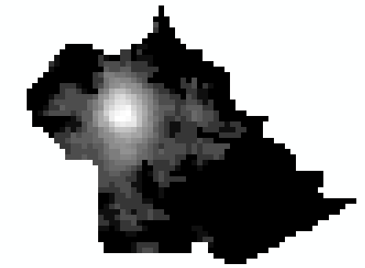 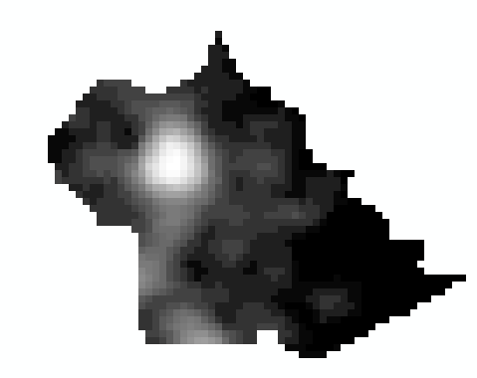

Figure 1: Barda Luminosity in 1992 Figure 2: Barda Luminosity in 2013